**AdventureWorks Dashboard: Chart Documentation**

This document provides an overview of the charts used in the AdventureWorks dashboard, their purpose, and whether they utilize DAX (Data Analysis Expressions) or not. Each chart is explained with its data source and functionality to aid in understanding the dashboard structure and analysis workflow.

Additionally, this document explains the purpose behind displaying each chart and how it aids in data analysis and decision-making.

Page summary

**Total Revenue and Profit Summary**

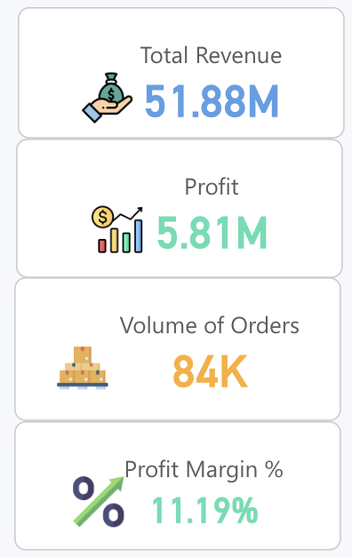

**Description**: Displays total revenue, profit, volume of orders, and profit margin percentage for the fiscal year.

**Visualization Type**: Card visual.

• **DAX Used**: Yes

Total Revenue = SUM(Sales[Sales Amount])

Profit = [Total Revenue] -[Total COGS]

Profit Margin % = DIVIDE([Total Revenue] - [Total COGS],[Total Revenue])

**Purpose**: Provides a quick snapshot of the company's financial performance, helping stakeholders assess overall profitability and sales volume at a glance.

**Sales and Sales YoY% by Month**

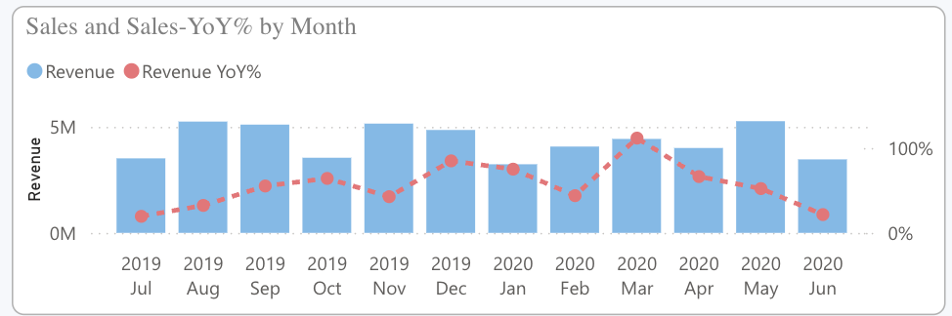

**Description**: Compares monthly sales revenue and year-over-year growth percentage.

**Visualization Type**: Line and clustered column chart.

**Data Source**:

* X-axis: Month
* Y-axis: SUM(Sales[Sales Amount])
* Line y-axis: DIVIDE([Total Revenue] - [Revenue Same Period Last Year], [Revenue Same Period Last Year])
* Revenue Same Period Last Year = CALCULATE([Total Revenue],SAMEPERIODLASTYEAR('Date'[Date]))

**Volume by Month**

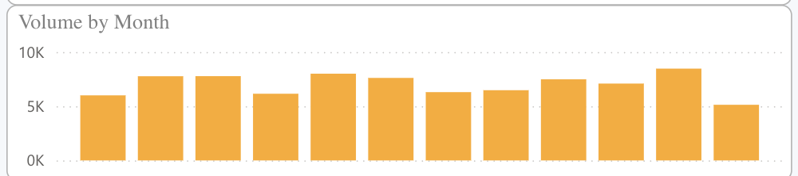

**Description**: Shows the total number of orders placed each month.

**Visualization Type**: Line and stacked column chart.

**Data Source**:

* X-axis: Month
* Column y-axis: Volume of Orders
  + Volume of Orders = COUNT(Sales[ProductKey])

**DAX Used**: No

**Purpose**: Highlights monthly order volumes, enabling analysis of demand trends and forecasting future order needs.

**Product Profitability Analysis**

Description: Scatter chart comparing average cost(trung bình giá vốn) ,sales price(giá bán lẻ), and gross profit margin for various products.

**Visualization Type**: Scatter chart.

**Data Source**:

* Values: Product
* X-Axis: Average Cost
  + Average Cost = AVERAGE(Sales[Product Standard Cost])
* Y-Axis: Average Sales Price
  + Average Sales Price = AVERAGE(Sales[Unit Price])
* Size: Gross Profit Margin All Product
  + Gross Profit Margin All Company = DIVIDE([Total Revenue] - [Total COGS],[Total Revenue])

**Purpose:** Helps identify the most and least profitable products, aiding in product line optimization and pricing strategy development.

**Calendar Heatmap**

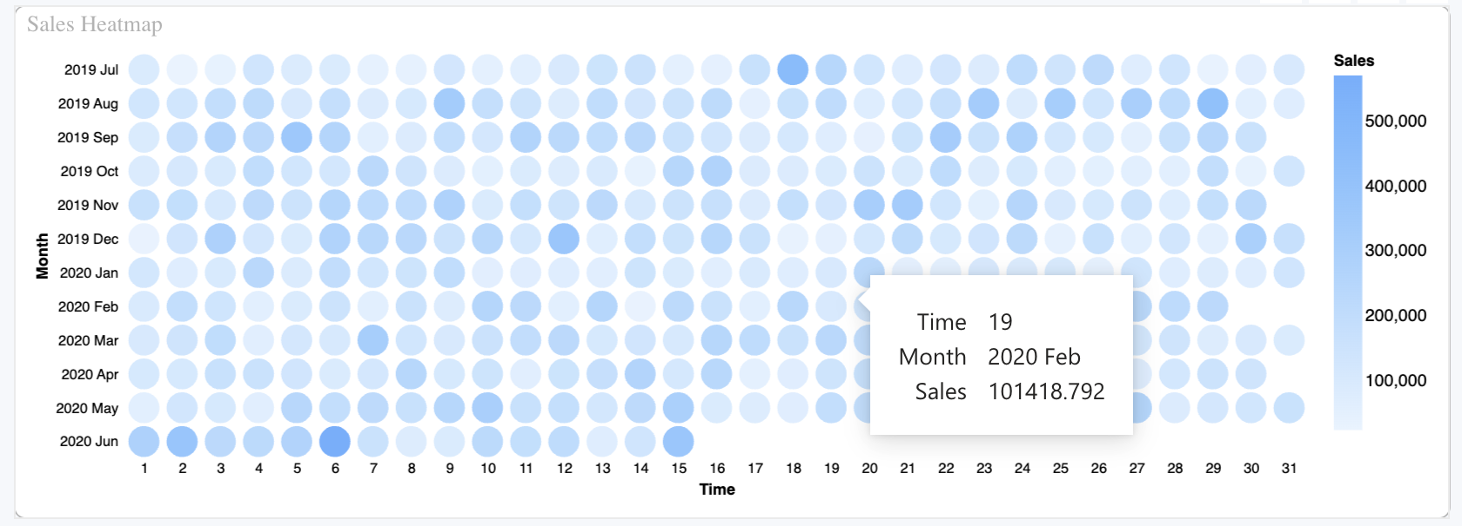

**Description**: Heatmap showing daily sales performance across months.

**Visualization Type**: Heatmap visual.(using Deneb chart External)

**Data Source**:

* Values: Day, Total Revenue, Month

**DAX Used**: No

**Purpose:** Provides a visual representation of sales density across days, allowing easy identification of peak sales periods and slower days.

**Holiday Season Performance**

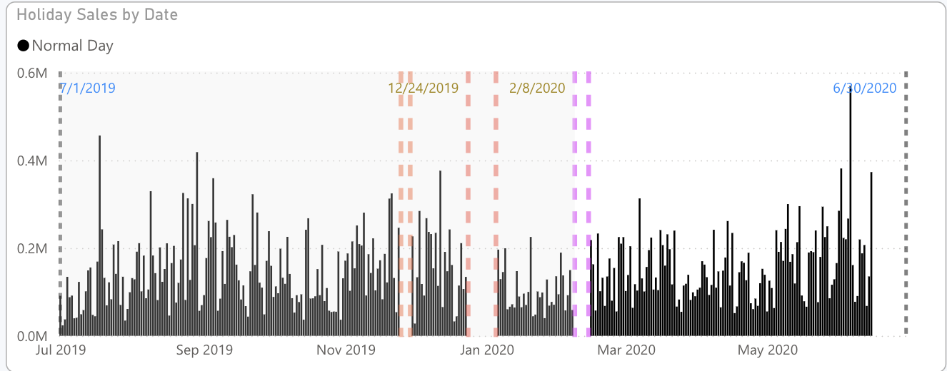

**Description**: Tracks sales trends during holidays, such as Christmas, Valentine and Thanksgiving.

**Visualization Type**: Line and clustered column chart with date filters.

**Data Source**:

* X-axis: Date
* Column y-axis: Total Revenue
* Column Legend: Holiday Season

Holiday Season =

SWITCH(

TRUE(),

'Date'[Date] >= DATE(2019, 11, 25) && 'Date'[Date] <= DATE(2019, 11, 29), "2019 Thanksgiving",

'Date'[Date] >= DATE(2019, 12, 24) && 'Date'[Date] <= DATE(2020, 1, 5), "2019 Christmas",

'Date'[Date] >= DATE(2020, 2, 8) && 'Date'[Date] <= DATE(2020, 2, 14), "2020 Valentine's Day",

"Normal Day"

)